Tecnichal report

Carlos Andres Celis Herrera

Workshop 4

User history

* As a user, I can subscribe to a newsletter, so receive a newsletter with the latest vehicles created.
* As an admin, I can recover the last deleted vehicle, so that I can have an insurance.

In this release of the vehicle management tool, we are asked to take the work of a previous developer, which we must correct and implement a new functionality, a new engine type and a memory structure for saving history and retrieving deleted objects.

Development

En primera medida se agregaron las estructuras para cumplir los requerimientos.

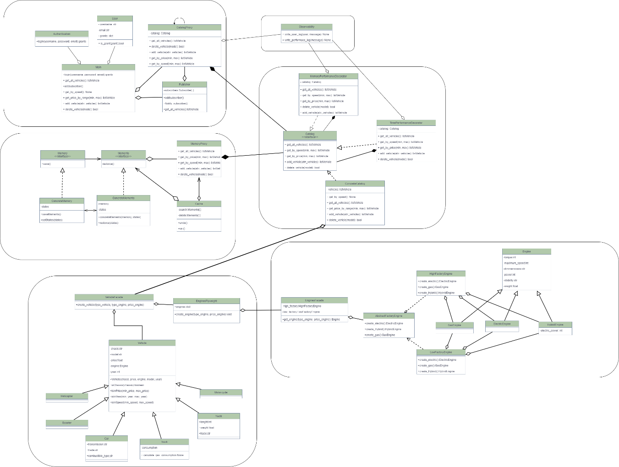

For the sending of the newsletter we used the observer design pattern, with which a class would save the subscribers and notify them, in the case of the three searches and the retrieval of the last deleted vehicle we opted for the memento design pattern with which we could identify different elements and save them in different lists, in our case it is of great help given the case of having two different types of objects to save.

On the other hand, a virtual environment was set up where the workshop was run, with the use of the virtualenv library.

Conclusion

To conclude, we were able to solve the errors in the virtual environment assembly, we also implemented the option to add users per run, although in that class the methods to notify and obtain the last 5 vehicles were missing. Also the memento structure and the new engine could not be implemented at the code level.